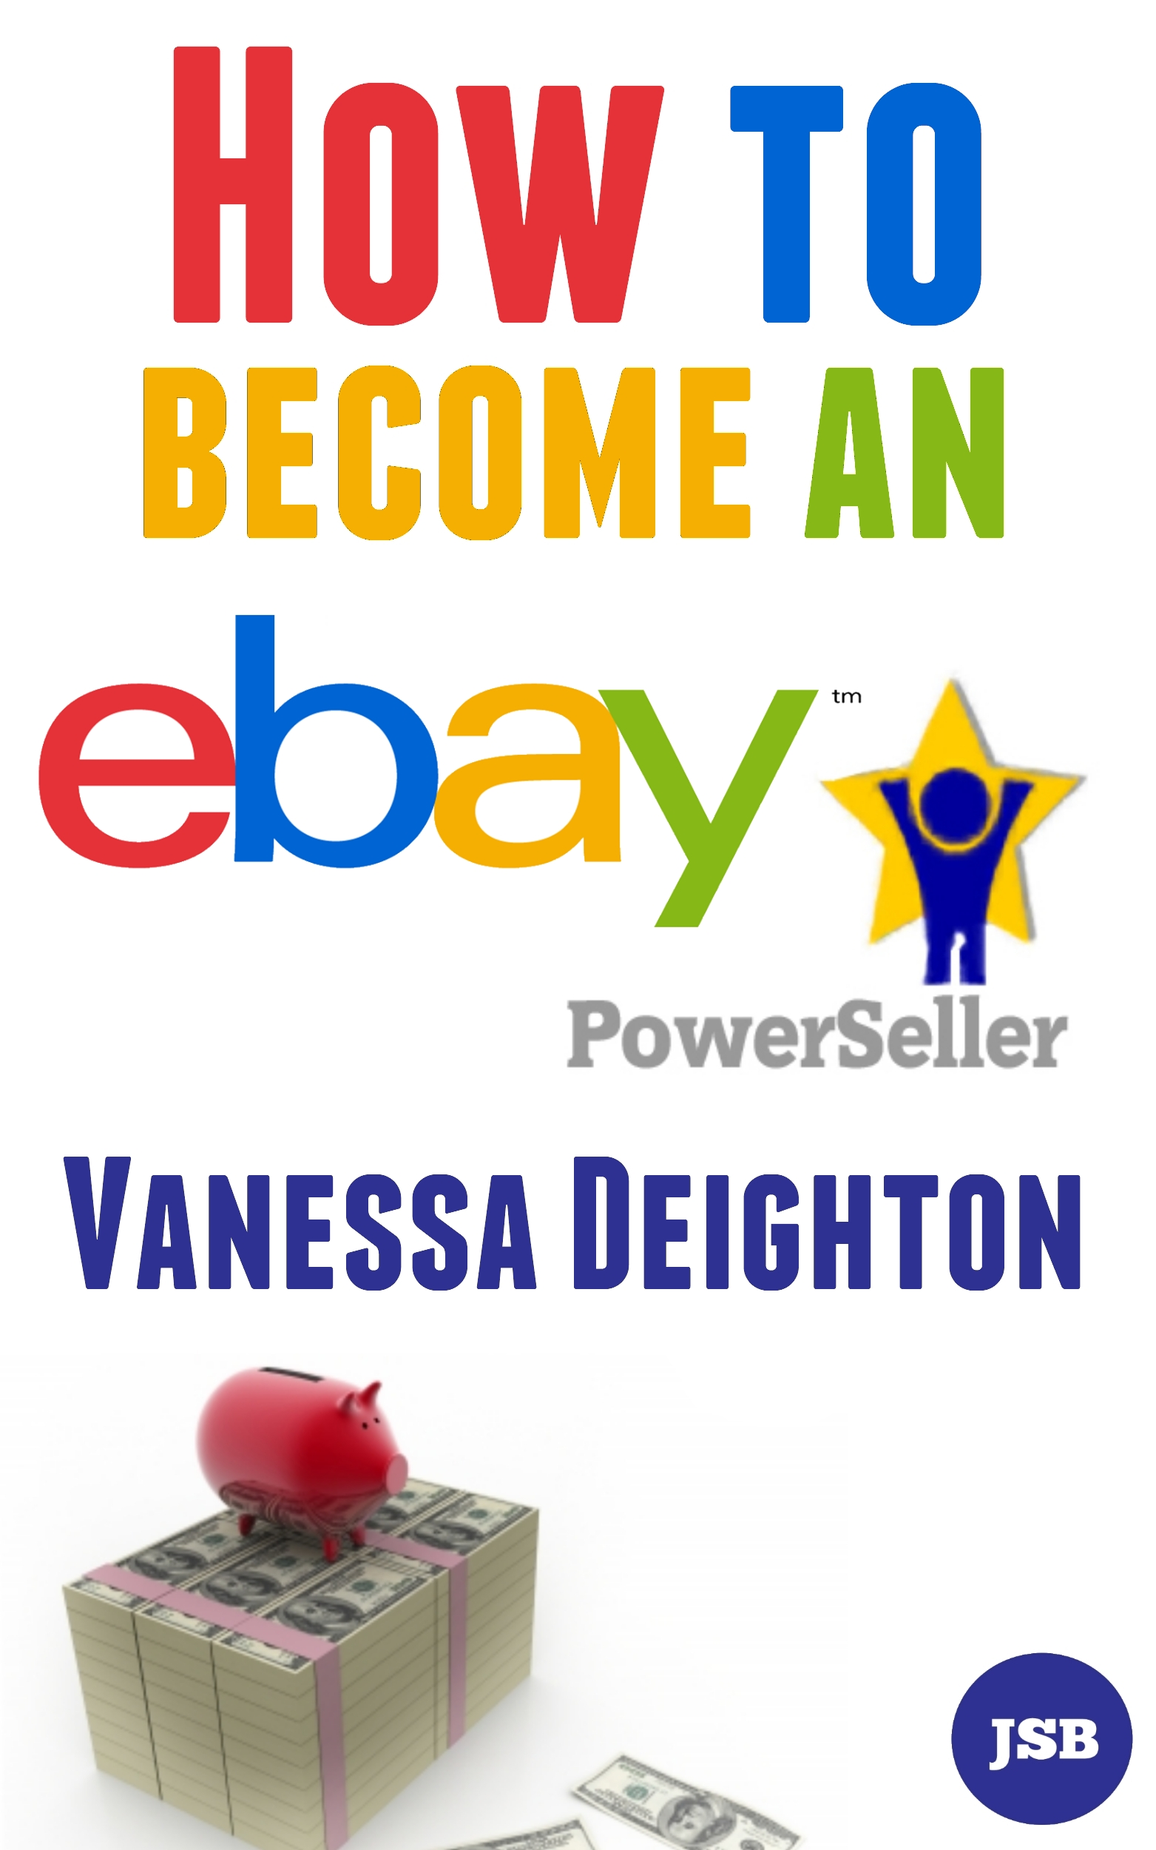

How To Become An eBay Power Seller
By Vanessa Deighton

Becoming a Power Seller on eBay isn’t something that happens to everyone, and this book is not something that will immediately make that happen. I have only been selling on eBay since November 2011 and I became a Power Seller by February 2012. Using my common sense and also making a few mistakes I have learned how to use eBay quickly and efficiently; you can too if you work hard at it.

The ideas in it are tried and tested, but they still require work in order to produce results. Like anything in life you have to make an effort to get somewhere. This book will show you the ‘how’ and the ‘where’, but only you can put in the effort.

So, what sells on eBay?
Pretty much everything, an aircraft carrier sold on the site. But that is not an invitation to head out to every supplier under the sun and buy whatever they have going cheap.

You’re going to have to specialize, at least at first. In my previous book, ‘Top 10 Tips For Making Money On eBay’ I talked about how being successful takes effort and hard work if you are going to get results. Making sure that you sell something that you know about is part of that work.

Get this bit wrong, and you’ll have a very frustrating time. So only sell something that you have at least a little bit of interest in.

But you also need a supplier. And this is another stumbling block; too many first time eBay sellers believe that they have to have actual premises to gain preferential trade prices. This is not true, the majority of suppliers are all too happy to offer you trade prices for sourcing supplies.

This is something that can help you gain not just better prices, but also a better long-term income. Having suppliers that you know are used to dealing with trade customers, and can offer you a great price too, can make a huge difference.

Source suppliers carefully. This means getting on the Web and finding a good supplier that knows your market. Go on forums to find out what people are using when it comes to suppliers in your niche.

Getting it right with suppliers is important, so you need to know what to do at the very first point of contact. Be polite but professional and make sure that you let the supplier know that they are dealing with someone who knows the product.

Then, make sure that you ask to buy the product in bulk. This will give you a good deal as regards to the price of the product and therefore the end profit that you will receive. This also goes further to reinforcing the idea in your buyer’s mind that you are a serious prospective business customer.

When it comes to getting your hands on these suppliers, there is also one other option that you can use. This is bulk buy websites; sites that specialize in finding bulk buy suppliers for your niche.

You could try Google to find wholesale sellers of goods in your niche but I have found these two websites that I think are the best places to find great deals as regards to bulk buying.

www.esources.co.uk

and

www.madeinchina.com

Take your time with buying that product…

I suggest a simple principle that you should be using when you are thinking of sourcing products. Try to spend at least a few weeks researching your product before you start buying it. This will allow you to gain even more knowledge about your product, and therefore allow you to feel confident when telling suppliers what you want.

When you research your product so that you know pretty much everything you could possibly know about it, you walk into any business transaction with an incredible amount of confidence. This helps when you are making decisions on what price to pay for the product.

Buy this eBook on Amazon at –

http://www.amazon.co.uk/Become-Powerseller-Vanessa-Deighton-ebook/dp/B009DZVX68/

Buy this eBook from Jed Samuel Books at –

www.jedsamuelbooks.yolasite.com/store.php

Visit the author’s websites at –

www.vanessadeighton.com
www.thesfmhomebusiness.com
www.pamperedpetsboutique.co.uk

