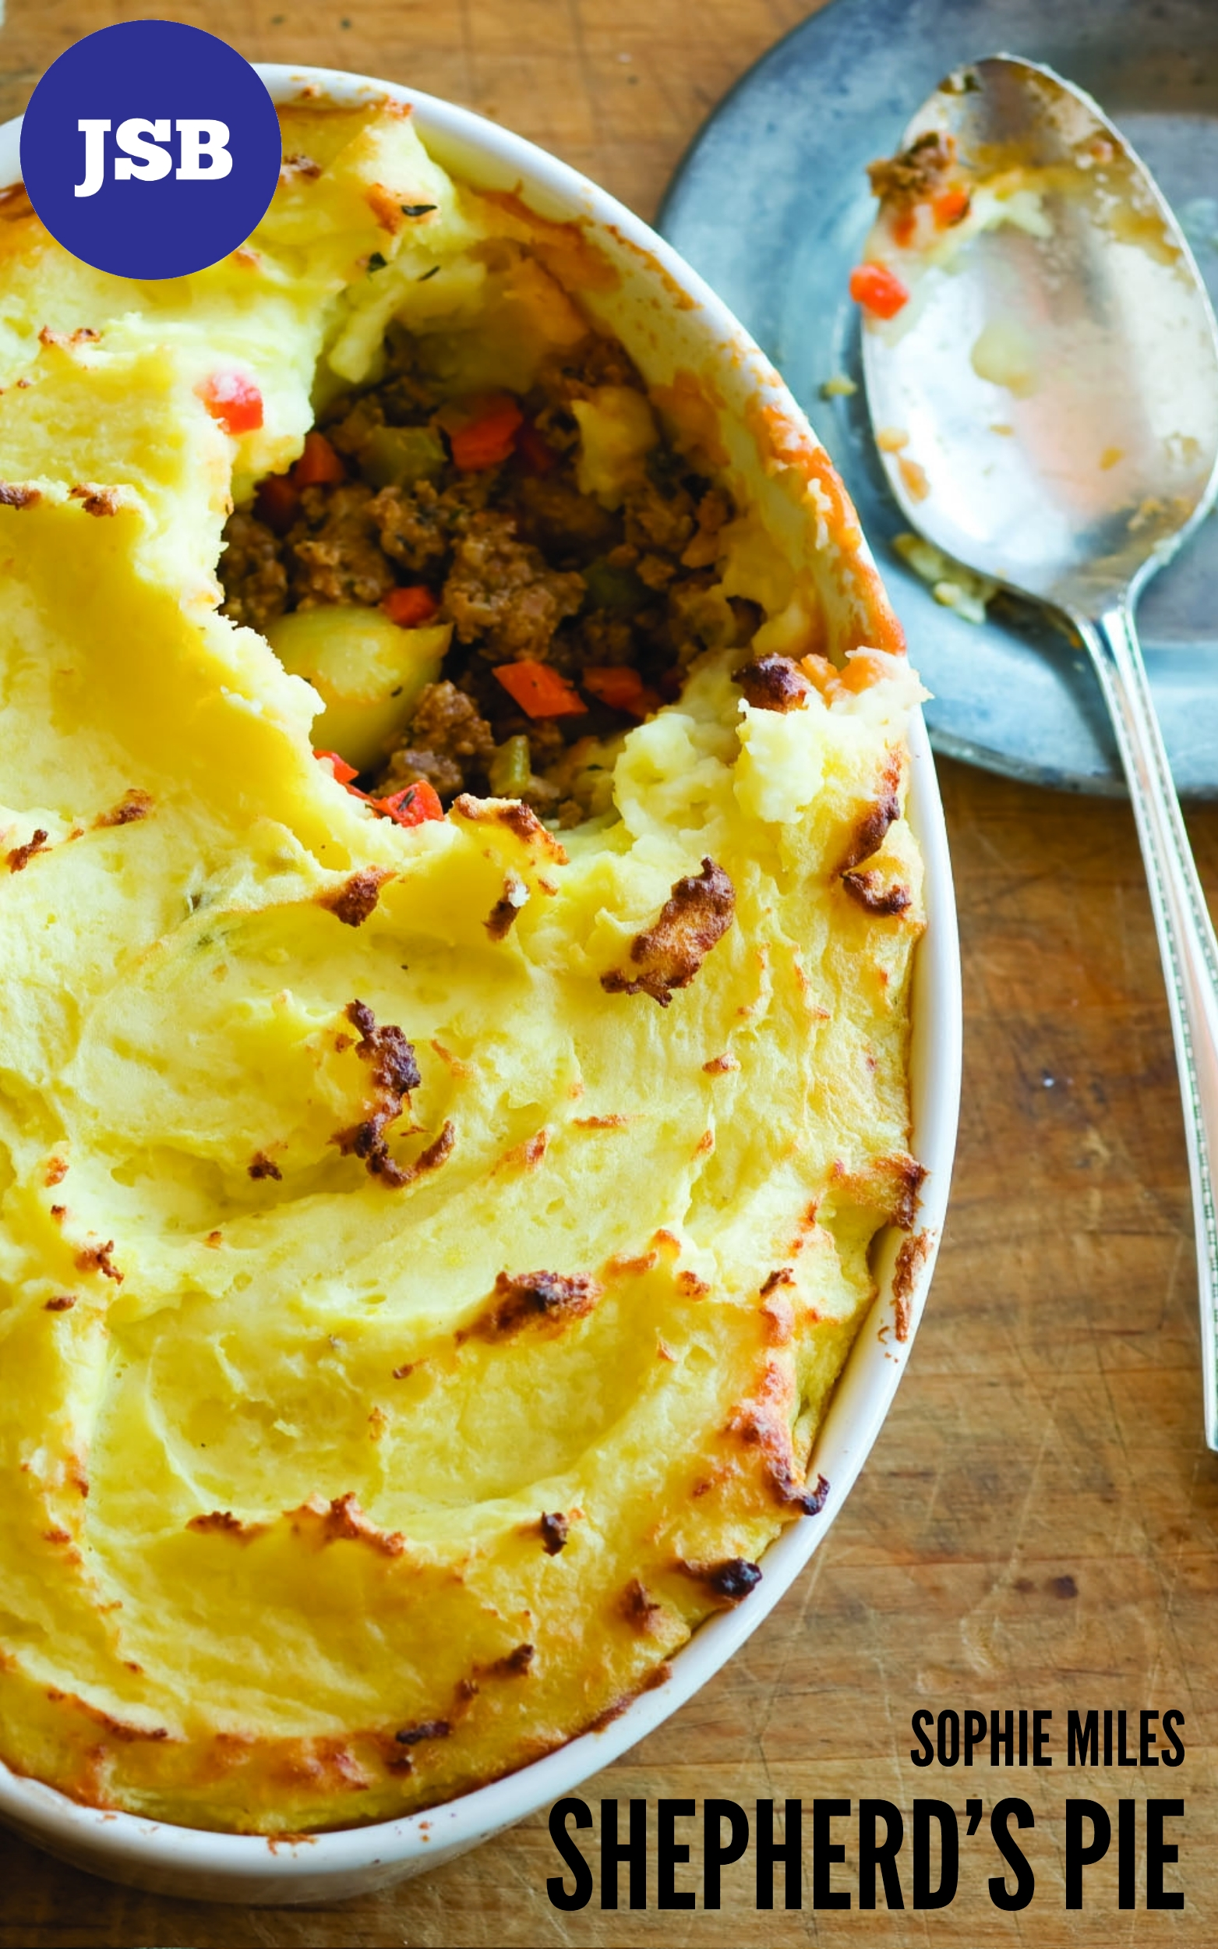

Shepherd’s Pie
By Sophie Miles

Jessica Bradford is an ordinary twenty eight year old woman, she’s stood in her living room, there are some empty cardboard boxes around. She’s next to a new sofa, cushions are on the floor and some plastic is scattered around.

This is not complicated. So why can’t I do it? It’s cushions, just cushions, for our new sofa. On the DFS website it says, “Beautiful scatter cushions provided, easy to organise, excite your colour scheme!” Yeah right, I’ve been looking at these cushions for at least twenty minutes. The delivery man was no help either, he might as well have talked gobbledegook for all the sense he made, “It's a brammer sofa, easy tae swatch efter, th' cushions shoods be easier enaw fur ye tae arrange, a bonny lass loch yerself.” I tried to nod intelligently, but I had no idea what in the world he was talking about. Relax, you know, I’m a grown woman; I was a top photographer! A real eye for the light, brilliant pictures, nobody could catch wildlife like I could.

My boyfriend, Scott, is the new advertising manager for the magazine YBS – Your Business Sense. We’ll have dinner parties and things to make better friends with his colleagues, so the arrangement of our cushions could be the difference between acquaintances and friends.

Ok, maybe making the bed wouldn’t be as difficult as arranging cushions. But then I heard a knock on the front door, I rushed to answer it. A really pretty woman was holding a dish and she said, “Mah name is Eliza, ah came to introduce myself, ah live next duir.” I reply that my name was Jessica. She only looked like she was in her early twenties but when she handed over some cottage pie, I noticed dirt under her fingernails.

She was friendly and explained that they’d moved here a few years ago, which explained how I could actually understand her. I’d been to Scotland a few times before, I said, when I took pictures for the National Geographic. I was really excited, the rolling hills, the beautiful wildlife; I was excited to be a housewife! I’d have time to explore!

Then she asked why I had cushions over the floor – how embarrassing. I mumbled something, but she just scooped them up. She put them alternately coloured and patterned, with lighter colours in the middle. It took me a minute or so to realise I had my mouth wide open. How did she do that? I’m a capable, grown woman – I’ll master it soon.

The next day in her bedroom, all the sheets and duvets are askew, she is in her pyjamas.

Millions of people are housewives! Millions of people change their sheets! Yesterday when I did our bed didn’t look a thing like the picture on the packaging. I mean, the duvet wasn’t in the cover properly, it was all folded over inside. And I couldn’t get the sheets over the corners properly, but I thought I covered the wrong bits well with our little cushions and a little teddy. Scott smiled when he saw our bed, then he gave me a big cuddle and told me I’d done a good job! He didn’t notice a thing wrong.

Jessica is stood in the kitchen, there are a lot of ingredients and utensils spread out around the kitchen messily. She has ingredients on her apron.

I’m gunna make a shepherd’s pie for Scott tonight, he loves it, and it must be really easy. It’s just mash and meat and stuff. I went to Tesco’s but I’m not sure if I bought some of the right things. The recipe said anchovy essence, so I bought a tin of anchovies, it can’t be so different. Jamie Oliver is never wrong.

Jessica is loading the dishwasher after Scott’s eaten.

Well, I was quite pleased with how it all went. I cooked the mince to perfection; in the recipe it said “brown the mince in a pan” so I put the lump of mince into the pan and it went brown. Well, it was almost black but mince is a dark colour anyway. And I added the anchovies to the sauce; I added the whole tin because I didn’t know how strong they were. I wasn’t sure if I cooked the shepherd’s pie right, it said 180C, but the highest my oven went to was 6. So I decided to just bung it in. It said 45 minutes, but I thought I’d leave it for at least an hour; it only went up to 6 after all.

I was so excited when Scott came home; the shepherd’s pie had been in there a good couple hours, it was bound to be done by now. Scott smelt it as soon as he walked through the door, so it must have been good. When I served it up to him he said, “That looks lovely!” It looked lovely! Lovely, he said! Something that I made by myself! He smiled and ate the whole lot! I couldn’t stop watching. I offered him seconds but he smiled and said that he couldn’t eat another bite; he was too full.

Jessica’s stood in the front doorway, she’s carrying several bags full of clothes.

I have to admit to Scott that I have no idea how the washing machine works. I mean, we need clean clothes. There’s one dial, and one button, how complicated can it be? But no, I couldn’t manage it; Scott’s silk shirt is fluorescent pink, and my dress – which was very expensive, even in the sale – is now the right size for a Barbie. I didn’t know what to do, so I went into town and spent, God, I don’t want to think how much, on replacing the clothes I trashed.

Jessica and Scott are sat at the table, in the kitchen having breakfast.

I have to do something. This morning, Scott made the bed – he’d started doing it but I never asked him to. He’s so cute, trying to help out around the house. He said to me, “Jessica, is this the shirt I was wearing Monday? Because I’m sure I spilt ink all down the side when I changed the printer cartridge, I didn’t take off my jacket for the rest of the day.” Damn, I thought. I’m such a terrible liar; my cheeks burned and I mumbled to him, “Oh yeah, I managed to get that out, I used this really good stain remover.” I was sure he’d seen through it.
Jessica and Eliza are stood in the kitchen, ingredients and utensils are spread out on the sides.

Eliza’s such a good cook! But, she didn’t know how to make shepherd’s pie, so I taught her after she showed me how to make lasagne. She showed me lots actually, how to cut the onions properly and everything!

Then Eliza said, “Ye kne, Scott seems really brammer and supportife. Yer quite lucky.”

But, I heard the postman and practically ran towards the door and the dreaded credit card bill; Scott’s bound to catch me out eventually. I mean, I spent a lot on replacing the clothes I ruined. A lot. It’s not like I can just say it was ordinary shopping, an expensive, ordinary shopping. I ripped apart the envelope, looked at the figure. I didn’t want to think about how many excuses I’d have to think of. But it said paid. Paid? Did Scott pay it automatically? If he carries on like this, it might work out in the end.

