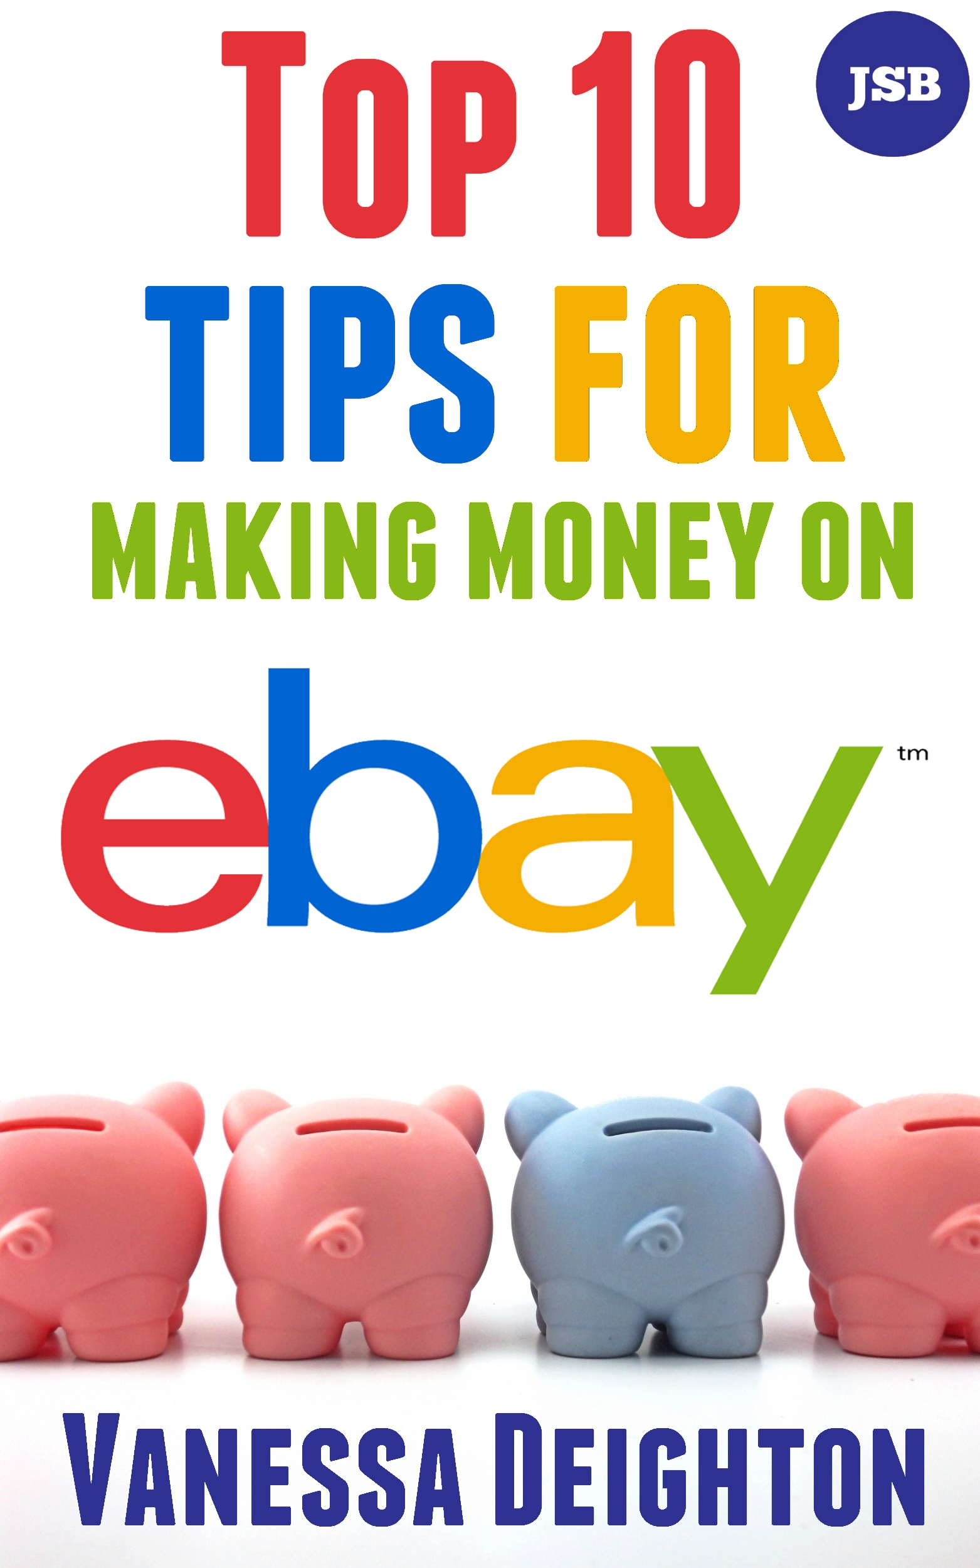

Top 10 Tips For Making Money On eBay
By Vanessa Deighton

Have you ever bought anything off eBay? Most of us have. And even if you haven’t, we have all heard about the worldwide sensation that the auction site – eBay.

With millions of transactions taking place on the site every year and the fact that anyone can create an item for sale on the site. It’s no surprise that so many people are turning to eBay to make extra income.

This report reveals ten secrets that will help you to become an eBay power seller. These secrets are known to just a few of the most successful power sellers that use eBay, and they have been developed through years of hard work.

Read on to find out how to maximize your chances of making some serious money with eBay by becoming a power seller, and if you like what you read, you may want to get your hands on my exclusive guide ‘How To Become An eBay Powerseller’.

I’m not one to mess about when it comes to something as important as eBay, so here we go with the first tip…

Top Tip Number One - Know your product
It is vitally important that you try and sell something that you know everything about.

It is almost impossible to exaggerate the need to sell what you know, even if it’s only at the beginning of your eBay career. This means picking a product or products that you are happy and knowledge of any answers to potential questions.

Anyone who buys something off the Internet will, nine times out of ten, have a question or two about the product. If answered promptly it will make it easier for them to feel like they want to buy from you. If you are able to show potential buyers that you can be trusted, because you know what you are selling and can resolve any problems regarding the product quickly. You will instantly gain credibility, credibility means sales.

Knowing the product inside out means that you will be able to respond quickly to any questions before a buyer decides to go elsewhere. Think about when you need help from a sales assistant in a real store and they can’t help you. It’s very frustrating. Or you find someone who would rather not sell to you because it is not the right product for you, but later you go back and buy something else because you trust them. If this has happened to you, you’ll understand why expertise is so important.

So your first tip towards becoming a power seller is to make sure that you start out selling products that you know a lot about.

Top Tip Number Two - Get the title right

The item title is the most important part of your listing. In fact, it is pretty safe to say that if your item title isn’t right, and if it doesn’t meet the requirements of your target market, you can pretty much kiss any profits goodbye.

Consider what your target buyer is likely to type into search engines or into eBay. They will go to where the keywords they use take them. You have to be certain that their key words match your title or your listings will not be seen.
For example, let us say that you have found yourself a niche in comic books. You want to list them using titles that match the search terms people will use.

For example:

Issue 10 ten Batman rare and unopened mint condition

Note how here I’ve used ‘ten’ and ‘10’, to cover both possibilities when people search for the items.

Also, I’ve used words that buyers will search for, like ‘rare’ and ‘unopened’. This is important to your potential buyers.

Be simple and clear and very effective.

Don’t make things complicated and obstructive by using characters that people just won’t enter on the keyboard, like in ‘best ever quality!!!!’

Top Tip Number Three - Be wary of the subtitle

Subtitles are something that mess up the world of eBay
They cost money to use and they do nothing for search. So if you use them, you are only going benefit if people are actually looking at your product. They will not use them to find your product.

Only use them if you have a high value product that needs extra information in a subtitle. This will add value when you are found.

Buy this eBook on Amazon at –

Buy this eBook from Jed Samuel Books at –

Visit the author’s websites at –

www.vanessadeighton.com
www.thesfmhomebusiness.com

