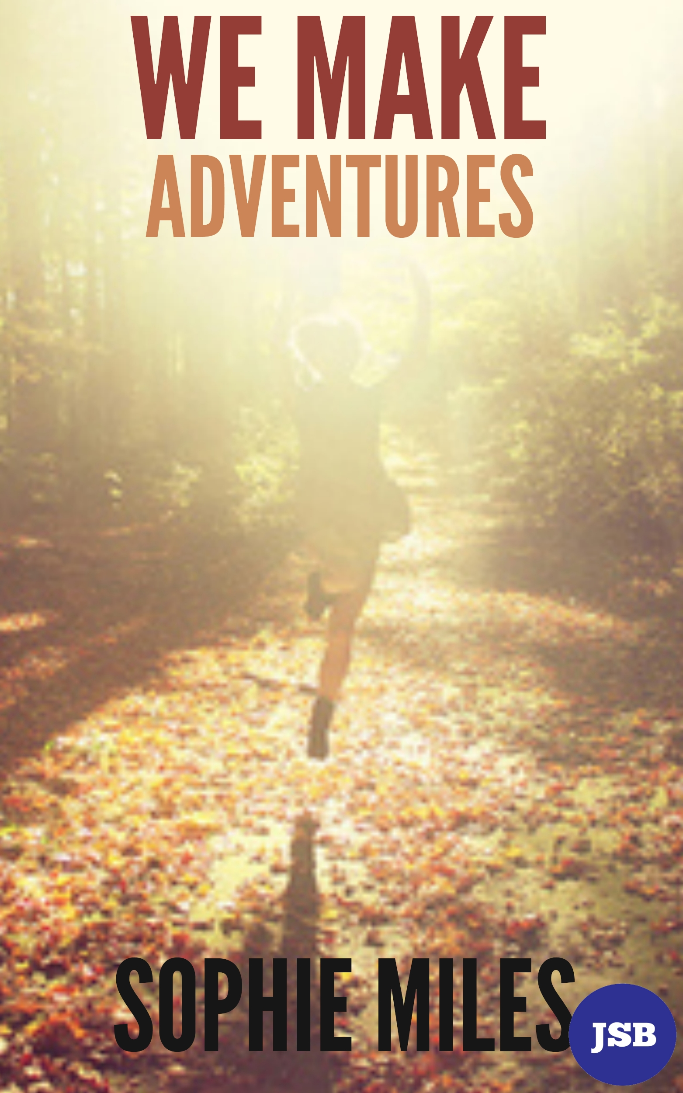
We Make Adventures
by Sophie Miles
We shot forward, barely skimming the throughway; stars flew past us as Shakira exploded from the speakers in a supernova of noise. Firing along the lanes, we were a blur of movement. Vast fields opened up like the emptiness of space, brightly lit houses becoming comets.
Screeching to a halt on the edge of the road, noise melted away into a faint lull. Everything faded except the chuckling of a stream, bobbles of wool were bouncing around the fields and the trees fluttered like lace. A jam of cars spread out in front like breadcrumbs leading us to Bampton fair.
Me, James (my boyfriend) and Linda (his curly haired mum) trampled towards the village. Pigeons flew away from the bumbling masses of people and the many stalls seemed to rise out of the ground, forming a castle that could be seen from all around. Towards the centre of the crowd, the sound of little feet pattering rose like a flock of birds. The streets were a higgledy-piggledy maze of pastel toned houses with stalls of bright colours that swirled around them like ribbon. From above it would be a mess of scribbles, like a child’s drawing.
Amongst the crowds of people, the distinctive voices of the flat-capped farmers could clearly be heard over the hubbub. Their wellies left a trail of mud behind them as they argued about hay quality and impregnating cows. Around them the crowd slowly dispersed into the many streets brimming with activity. Smells of cheeses, breads, cakes and perfumes quickly overcame the farmers’ odour and mixed into a delectable scent in the air.
We stopped every few paces to talk to people we knew, progressing very slowly up the crowded street. We walked towards one stall full of glittering bracelets and beads. The woman behind it, Lucy, greeted us warmly; she was pretty with wide cheeks like a child and dark eyelashes on a pale complexion. We met first a few months ago, whilst she was at Bampton school fete, and then she had painted my face in a replica of a tiger. She probably remembered me and James in particular, as we were the only people over seven to sit down at her feet and close our eyes in excited expectation of our faces being transformed into a ferocious animal. Or maybe just a cat.
Bampton had hundreds of pockets of energy, each selling an array of food, jewellery, gifts and sweets that lined the edges of the streets. Children flocked around the horse’s pen. It raised his head, nuzzling his owner lovingly, like Pegasus would gaze at Hercules. Everyone pushed their fingers between the bars and tried to stroke the creature. No matter your age, you always give in to the childish impulse to stroke it yourself. Where; after you try to get a sneaky touch, the horse turns around and you get a view of its bottom.
Dodging the children, I run stumbling after James from stall to stall, grinning and laughing. A Greek man passed me some concoction of olives and something green and I politely ate it. It was disgusting. It burned like I’d bitten into a dragon’s egg and it was taking its revenge on the poor soft skin inside my mouth. The next stall had a delectable selection of cheeses; the vintage mature cheddar set my taste buds alight. Glancing at the “take one” sign, I cheekily took one large handful, hoping the woman behind the stall didn’t see. I noticed James taking several of the last pieces too. Another was a smoky cheese; it felt like the dragon had returned with vengeance, breathing down my throat.
One particularly scary woman, glared down at her helpless child, with Ariel splashed across her top and a tiara balancing on her head. “Where did you get those sugar-filled horrors?” she screeched, her face screwed up like she was gripped in a sugar-induced frenzy. Immune to the girl’s innocent chocolate eyes, she snatched her small bag of sweets out of her hand; the girl began to wail and everyone turned to look. It was the highest, blood curdling scream, but the wicked witch was immune to the princess’s pleas.
As me and James ambled along, past all the mothers and children in the crowd, one girl’s face caught my eye. My mind swirled with memories until I found an image of a freckle-covered infant. I beamed as I walked towards the best friend of my childhood. We exchanged pleasantries, but all too quickly the conversation fizzled out. With so many years of separation, we no longer knew each other; the startling contrast between my memories and the person before me was overwhelming. We walked away from each other, once again.
James and I knew this time would come. The time we had to start to part with our carefully guarded pennies. We couldn’t go through the whole day with just free tasters; it was starting to get late, and some of the stars had become faint glows against the inky sky as we ambled to the last few stalls.
At the last stall we saw extravagant designs of jewellery, cut like crowns. So, parting with money intended for textbooks, we bought some friendship bracelets; yellow and purple and blue and pink were all intertwined, all completely different and contrasting, but the colours all fitted together like puzzle pieces. I always knew how different James and I were, but he’s my best friend in the whole world and I tell him everything. He’s my puzzle piece, we fit together; he makes my tummy flutter, and my heart beat faster, and he holds my hand tightly. We can make adventures from any day, any normal day; everything becomes exciting, like a child with the most amazing toy, just because we’re together. Even in Bampton.

